Lesson plan using micro:bit
Truth or Dare Activity
Cre

Editor: Goulitsa Paraskevi –High School of Assopia

Introduction

This project teaches you how to use button inputs and LED outputs to create a fun “truth or dare” game using micro: bit!

Learning objectives
The students can:
- Display own patterns on the leds
- Create a randomly generated variable
- Use an IF …THEN…ELSE
- Run two programming blocks at once
- Standards alignment
- Uses logical reasoning to predict outcomes
- Designs simple algorithms using selection
- Understands that programming bridges the gap between algorithmic solutions and computers
- Detects and corrects errors i.e debugging in algorithms

Step one:

The user presses the A button to see a randomly generated statement

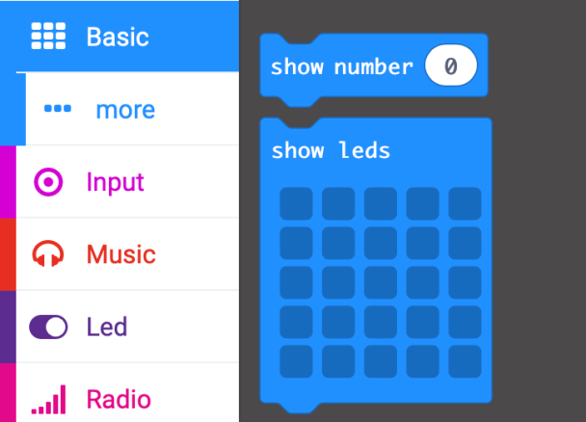

Drag the “Show leds” block onto the workspace and draw the pattern by clicking on the boxes that you want to light up. A white square indicates LED on.

To ensure the LEDs are always shown, the LEDs are to be placed within a forever loop. The loop can be found from the basic option from the block menu. Drag the block and place around the LEDs.

Step Two
The next part of the program displays a random statement once the user has pressed a button. Select the Input option from the block menu and find the “On button press” block and drag onto the workspace.

The result of the random function needs to be stored within a variable. From the block menu select the “Variable” and click “Make a Variable”.

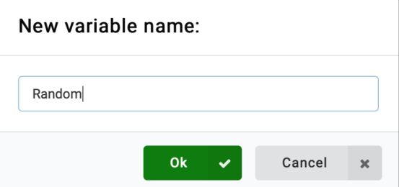
A popup dialogue box will then ask you to name your variable. In this example name it “Random”.

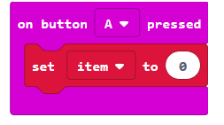
Using the “set item” block, drag it onto the workspace and connect to the button “A” input block.

Step Three
Now the variable “Random” has been created this can be found on the “Set item” drop down menu by pressing the down arrow and selecting “Random’’
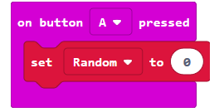

Now that the variable is set to “0” when the A button is pressed, we now need to assign a random number to it. From the block menu select the “Math” option and select “pick random 0 to 10”

Drag the “pick random” block onto the workspace and join to the “set random” block. A random number between 0 and 1 will give us the 2 options needed.
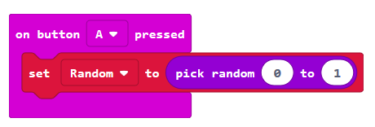

Step Four

Now we include a selection process using the IF statements found within the “logic” option within the block menu.

Drag the “IF” block into the workspace and connect it to follow the “random” block; click '+' to add 'else' to the block.
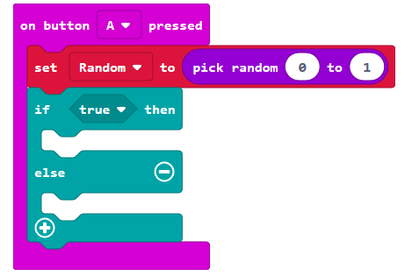

Step Five
To ensure the micro:bit bases the IF statement on the random number, the value stored in the variable “Random” needs to be checked. The “Random” variable can be found from the 'variables' option in the block menu.
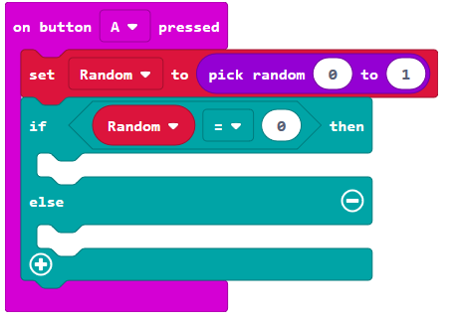

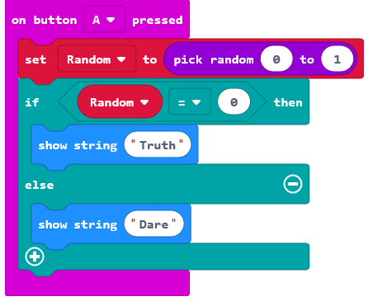
The program is completed and both elements will work together at the same time, displaying the led arrow pattern, when the button hasn’t been pressed.

Save the project and give the name “truth or dare”.

Challenges
Well done for completing the ‘Truth or Dare’ project. Now you can see it working, try to modify your code so it does some or all of the challenges below.
- Add the ‘Number of players’ in the game and display who is playing.
- Add different directions of the arrow.
- Add an animation of the arrow spinning.
- Add a score based system whether completed the truth or dare.

