Activity 1 to know the micro:bit
Basic commands

Follow the link: https://microbit.org/
Give the name smiley face to the project

Activity 1: Smiley face
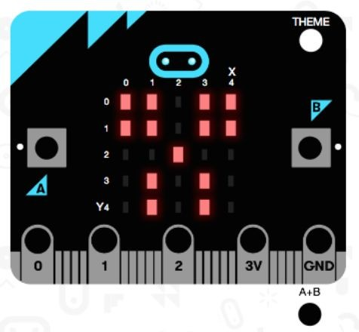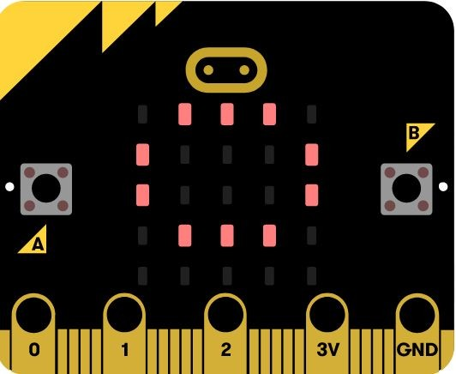Task: Make a smiling face, then run it on the emulator. What other shapes, pictures can you get it to display?

Don’t forget to save the project

